
TIP SHEET # 4

Supporting Students with Vision Loss:
Considerations for Special Education Administrators

This Tip Sheet is aimed at helping Special Education Administrators weigh the various factors involved with providing appropriate services to students with visual impairments. NH has a long history of finding creative ways to provide service to students with visual impairments, with responsibility shared between local budgets, supplemented with limited state support.

Who are students with Visual Impairments?

Students with visual impairments are those who are blind, those with limited vision, or those with degenerative vision conditions.
The State of New Hampshire has chosen to use functional definitions for determining which students are visually impaired, as opposed to labels such as “legally blind”. Under IDEIA 2004, both academic and “functional” areas, such as social skills, self-care, and navigating the environment, all need to be considered in determining the services required for any particular student. Except in rare circumstances, 504 plans do not provide the appropriate level of support for this group of students.

What are “appropriate” services for students with visual impairments?

While “appropriate” is not defined in federal law or regulation, there is a body of work specific to students with visual impairments that provides guidance. The Expanded Core Curriculum (ECC), developed by professionals and parents with expertise in the area of visual impairments, offers nine (9) areas of focus for students with this disability. For some students, an extended school day or school year may be recommended in order to allow the time to provide all necessary aspects of the expanded core curriculum, consistent with NH Rules.

For more information on the ECC, go to: http://www.tsbvi.edu/Education/corecurriculum.htm . A NH PD Center Tip Sheet (#2) has also been published on this subject and is posted on the project’s website along with all other published Tip Sheets: www.nercve.umb.edu/nhpd
One of the overriding concerns of students, parents and professionals is the potential social isolation of students with visual impairment.
As an unintended consequence of inclusion, those few students with visual impairment can often be “excluded” in many of the social and recreational experiences that come naturally to sighted children. This lack of exposure can have long-term impact, in such areas as the options considered for careers and employment. Imagine, for example, how many visual images of careers and vocations that sighted children observe from a very early age. This reinforces the need to include Career Education among the services for students with visual impairment.

The Team Process – Who Needs to Participate?

Depending upon the needs of the individual student, you will include a Teacher of the Visually Impaired (TVI), and/or a specialist in Orientation and Mobility (O&M) for varying levels of support. For students who are blind, O & M is almost certainly going to be part of the student’s program. Assistive technology is also a critical service for these students, and teams should seek out the services of a skilled AT evaluator to determine the best technology for the student to use in accessing the general curriculum. Assistive technology will play a lifelong role in the success of individuals with vision loss. In addition, teams need to make sure that parents play a central role in determining goals and priorities. Parents sometimes complain that they are presented with a completed document at the IEP meeting, often with very little of their input. For students who are visually impaired, parents must be involved in determining both short- and long-term goals for their child. As with other students with disabilities, students with visual impairments also need to be part of the IEP team, as appropriate for the student’s age.
Where can you find resources?

As noted above, New Hampshire has used a variety of creative solutions to serve the needs of students with visual impairments, given the relative low incidence of vision impairment. State-wide figures in December 2007 indicated that there were 127 students with “visual impairment” as their primary disability. One hundred or more students have visual impairment listed as a secondary or tertiary disability. Also, many students with the primary disability of “multiple disability” have some level of vision impairment. Presently, there are 24 teachers of the visually impaired working in New Hampshire, most of them itinerant, each covering many school districts. Additionally, there are several Orientation and Mobility Specialists working in NH school districts. Information on how to hire these critical specialists is available through the NH Vision and Hearing Network (www.nhvhn.org). NHVHN is funded by the NH DOE to support the educational needs of students with vision or hearing loss, and employs educational consultants that are available to school districts in the state. Other states offer different approaches, including State-supported schools for the Blind and Visually Impaired. Texas, for one, has developed a wide variety of residential and outreach services to serve its students. Their website, shown at the end of this Tip Sheet, has many useful resources and documents. The National Association of State Directors of Special Education, or NASDSE, published a book entitled Blind and Visually Impaired Students: Educational Services Guidelines, which can be borrowed from the NHPD Center for Vision Education library; this provides one of the best overviews of services for students with visual impairments

Concerns and Possible Pitfalls:

As with many low-incidence disabilities, it is virtually impossible for a local director to be an “expert” in vision loss. It is essential, therefore, that each director knows how and where to access the necessary expertise for students with visual
impairments.

The credibility and availability of a TVI, and/or an O & M specialist, is essential to providing the appropriate services. The NH Vision and Hearing Network, based in Concord, can help in the search for qualified providers, whether for assessment, consultation, or direct services. Teachers of the Visually Impaired can be obtained through SERESC, NH Association for the Blind, and Strafford Learning Center. Obtaining appropriate materials, including large-print or Braille books, can sometimes take weeks and even months, unless some long-range planning occurs at the district level. For inclusion to work for the student with a visual impairment, appropriate materials that allow access to the general curriculum need to be available on a timely basis. The Instructional Materials Center at the NH Vision and Hearing Network (NHVHN) can assist you with obtaining these materials. It is imperative to make those requests as soon as you anticipate the need, to allow sufficient time for NHVHN to research where and when these materials can be obtained. In some cases, federal funds provided through the American Printing House for the Blind can be used to purchase educational materials.

Students with visual impairments have unique needs that require specialized instruction and supports. When these students are in your district, the resources listed here and found on the websites below should be of assistance to you as you plan for the appropriate services.

References:

Texas School for the Blind and Visually Impaired:
http://www.tsbvi.edu

NH Professional Development Center for Vision Education:
www.nercve.umb.edu/nhpd
(Great info on conferences, training, resources)

You can also go to a flyer that gives you a great overview for directors, at:
http://www.tsbvi.edu/agenda/flyer.htm

There are documents on the National Agenda as well as our own NH Agenda, at: www.nhbvi.com

For more information, contact
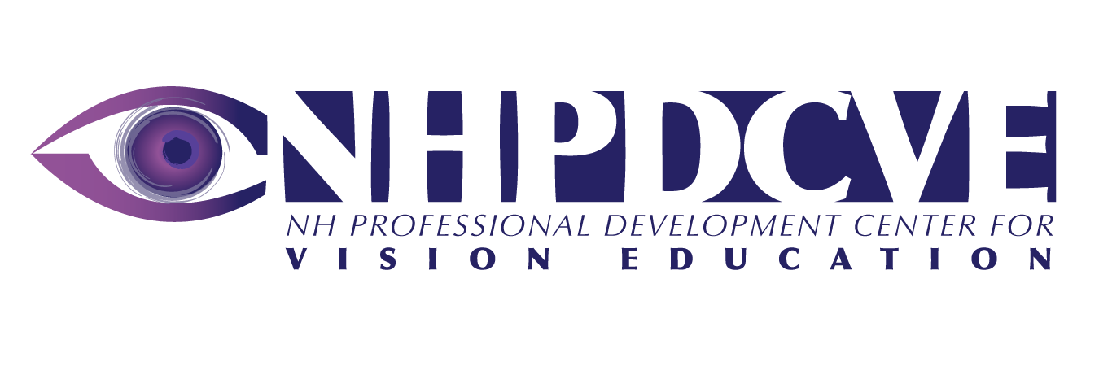
ATECH Services
117 Pleasant Street, Dolloff Building
Concord, NH 03301
603.226.2900
This tip sheet was written by:
P. Alan Pardy, Ed.D.
Executive Director
NH Association of Special Education Administrators

This publication was developed in 2008 under a grant from the NH DOE, Office of Special Education. It is available for download at www.nercve.umb.edu/nhpd

