
TIP SHEET # 5

Access to Assistive Technology
For Students with Vision Loss

Assistive Technology covers the wide range of adaptive techniques, as well as equipment, used by anyone who has difficulty performing a task, but especially reading, writing or using a computer. As we aim towards a goal of having all children provided with the same educational opportunities despite their differences, we need to include Assistive Technology in the process of evaluation of a child’s needs.

A student who displays difficulty performing any classroom or play activity can benefit from an assistive technology evaluation to see if they’re performing to the best of their abilities, or if an adapted or assistive device would be helpful. Holding material very close to the eyes, leaning very close to the desk in order to see what they are doing, needing lots of light but being bothered by glare—these are all signs of a child needing their vision assessed to determine what is going on with their eyes and what might be helpful.

All students with a vision loss need to be provided with an assistive technology evaluation and follow-up training on how to use the technology while in school. These technologies, whether low or high tech, will be lifelong supports to these students, enhancing their ability to independently function as adults at work and at home. The NH Agenda, in its 2004 publication entitled “Services for Children with Visual Impairments” states that an initial evaluation to determine appropriate assistive technology should occur no later than age 7-8.

An evaluator trained in low vision/blindness and the technology available for children to function more independently is the best person to perform an Assistive Technology evaluation. In NH, schools or parents can contact the NH Vision/Hearing Network (www.nhvhn.org) to obtain assistance in identifying the best evaluator for the student and to schedule the evaluation and training required.

An Assistive Technology Evaluation consists of observing the child in their environment while performing specific tasks. Then, adaptive techniques or equipment are tried with the child to see how they work to help the child perform a specific task more independently. A report is written in which recommendations are made according to the child’s performance of these tasks with the adaptive techniques and assistive technology.

Teachers and parents are very important as members of the team in observing the child’s functioning in school and play activities. It is important for the evaluator to have a chance to discuss with parents and teachers where the student needs support to have equal access to the classroom and school environment, including the playground, cafeteria, art room, music room, etc.

Once an assistive technology evaluation is scheduled, have ready those things that the child would need to use—books they need for school as well as those for pleasure reading (i.e., textbooks, paperbacks, sheets handed out in the classroom, etc.); papers the child would write on for various subjects (i.e., math, spelling, a journal, etc.); and, access to a computer to see how well they can access applications, the internet and games. The sooner an Assistive Technology Evaluation and follow-up training is provided, the better the student will be able to perform tasks in the classroom and at home.

Adaptations and assistive technology for students with vision loss can be low or high tech. It can be as simple as increasing contrast, making things appear larger by bringing materials closer using magnification, or using direct (task) lighting. Or the student may require more sophisticated technology such as computer software which allows the computer to talk to you, or listen to you talk to it, such as Jaws, Kurzweil, and Naturally Speaking.

Here’s a sampling of some of the assistive technology available for students with vision loss:

Electronic notetakers:
- Digital voice recorders, which no longer use tape
- Personal Digital Assistant (PDA), such as Palm Pilot, with adaptations such as Maestro, a person with no vision can use one to allow for independent access of notes, phone numbers, reminders, appointments, etc.
- BrailleNote, PacMate, and Braille and Speak are a few of the high tech notetaking systems that are available to students to input both print and braille to be converted to the appropriate medium for both student and teacher

USB memory sticks:
- Make software programs portable, so that the software that a student uses can be accessed easily from any computer in the school or home

Scanners:
- Can put text into computers where it can be read out loud

Closed Circuit Televisions (CCTV) allow for:
- printed material and photos to be viewed with more ease
- split screens when attached to computers
- distance, intermediate and near viewing
- different color selections to increase contrast for reading and writing.

CCTVs have become sleek and now take up less room than a desktop computer. Portable models allow for easy transport, and connect to televisions and/or computers or display panels. Some can even be worn on the head so the image is viewed through goggle-like glasses when a screen/monitor is not available.

Since so much is available now it is always a good idea to compare the options you have before obtaining an adapted device. For most students, it will be a combination of AT devices that will provide the best access to the curriculum and the school environment. Sometimes more than one device is necessary. For example, it may be important to have portability for one student for most of the day, but that portable device may not be the best solution in other ways. This may mean the one solution that meets most of their needs is not the best option all of the time.

Access to and appropriate use of assistive technology is a critical factor in the education of students with vision loss. Best practice indicates that schools should:
- assess a student’s abilities to function in all areas,
- identify the adaptations and technology that will enhance and support independent functioning, and
- provide the appropriate training so that technology can be used effectively.

RESOURCES
www.adaptivetech.net
This website gives information about all the adaptive software/hardware talked about in this tip sheet.
www.afb.org
American Foundation for the Blind
www.afb.org/accessworld.asp
AccessWorld Technology for Consumers with Vision Loss
www.apple.com
Apple/Mac computer accessibility adaptations
www.microsoft.com
Microsoft computer accessibility adaptations
www.noah-health.org
A wonderful site for information on health, but the eye specifically
www.rfbd.org
Recording for the Blind and Dyslexic (RFB&D)

For more information, contact
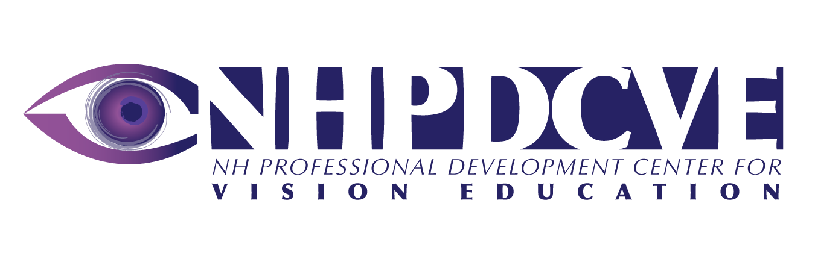
ATECH Services
117 Pleasant Street, Dolloff Building
Concord, NH 03301 603.226.2900

This Tip Sheet was written by
This publication was developed in 2008 under a grant from the NH DOE, Office of Special Education. It is available for download at www.nercve.umb.edu/nhpd

Chrys Peralta, OTR/L
Occupational Therapist
With help from Amy Halloran and Amantha Moore
Adaptive Technology Consulting
Salisbury, MA 01952

